Estimating LLM Training FLOPs on the

Nvidia Jetson Orin Nano

William Fowler

Introduction

Motivation

In want of a quantifiable way to decide what counts as a frontier AI model, compute thresholds have emerged as the standard for AI policy that has actually made it into law: California’s SB 53 uses 10^26 floating-point operations (FLOPs) in the training run as the threshold for what counts as a frontier model and the EU AI Act applies the same categorization at 10^25. Proposals for international AI agreements^{[1][2][3]} extend the use of training FLOPs to determine part or all of the threshold for what counts as a frontier model under the agreement. Current AI laws have no way of actually verifying AI companies’ claims about the number of FLOPs used in training and instead just rely on self-reports, but an international AI agreement should assume adversarial behavior from each involved party. As such, it would be helpful if we had some way of verifying the number of FLOPs used in an LLM training run through system-level GPU readings, that way AI developers’ code and data could remain hidden from the verifiers of the AI agreement, but allow verification of training FLOPs even under conditions where the model training might be adversarial. My work builds a Minimum Viable Product (MVP) for how this verification could work on an Nvidia Jetson Orin Nano.

Related Work

EpochAI have done work on estimating the number of training FLOPs using (1) insider knowledge about the model architecture and (2) open-source reports of the number of accelerators, amount of time used in training runs, and expected utilization rate. My estimator extends upon their method (2) to include power-monitoring and real-time data on utilization.

Chaurhuri et al. demonstrate how thermal and power side-channels along with assumptions about model architecture can be used to extract information about transformer model weights during a training run. While an explicit goal of AI treaty verification is to NOT expose model secrets to the verifiers, this shows that extracting information about transformer training runs through side-channels is possible.

Recently, Rahman and Tajdari showed how GPU system-level readings could be used to classify AI workloads as training vs. inference.

Methodology

Hardware and Observable Signals

All experiments are run on an Nvidia Jetson Orin Nano 8 GB developer kit. This is essentially Nvidia’s version of the Raspberry Pi, a single-board computer used for small-scale experiments and edge computing, but with an Ampere GPU. To estimate FLOPs, we run a sample ML training script on the Nano and then observe the following signals:

- Power (W): The Nano comes with an onboard INA3221 sensor which measures the power consumed by the board. Notably, this includes power consumed by both the CPU and GPU, but while an LLM training workload is actively running, we can expect GPU power to dominate the reading.
- Memory Bandwidth Utilization (%): Actmon is a system-level process which reports whether the External Memory Controller (EMC) is active. The EMC is the hardware block which manages the transfer of data between the GPU and DRAM. What reading this does not tell us is how much data is transferred, just whether or not the controller is active. Still, a higher EMC utilization suggests there is a lot of data that needs to be transferred to and from the GPU from DRAM which can be indicative of a training run happening.

Constructing Sample Workloads

The Nano is not a device that is suitable for running an actual LLM training workload, so instead I use a script that mimics the behavior of a real training workload (initializes a transformer and does feedforwards and backprop on random data for a preset number of steps) under different hyperparameter configurations: batch size, sequence length, number of attention heads, dimension of the MLP, number of layers, and precision.

While the sample training run script can simulate a workload with any value of hyperparameters, we only care about the FLOP estimator being accurate on workloads which emulate a realistic training run that an AI developer might actually do. In practice, we’d expect an AI developer to want to fully utilize their GPUs as best as they can, so I define “frontier” sample training runs as ones in which the GPU is active at least 80% of the time. Note, this is different from the EMC bandwidth utilization percentage which is measuring how often the memory controller is running.

Ground Truth Computation

Getting the number of algorithmic FLOPs is much easier if you, unlike our FLOP estimator, have access to the underlying training script and can directly pull the dimensions of the model and other configurations of the training run. This is what Pytorch’s FlopCounterMode library does. It has preset formulas for determining the number of algorithmic FLOPs used in a training script based on the dimensions of the matrices being multiplied on the operations being performed.

The FLOP Estimator

The estimator’s algorithm is shown below in equation (1).

- TFLOPs = (E_net - E_per_TB * TB_moved - E_overhead * t) / E_PER_TFLOP

I explain terms below, but first, let me motivate on a high level what this equation is doing. In the simplest case, we would like to just figure out how much energy the GPU is using, calibrate our Energy_Per_TFLOP parameter based on a bunch of workloads with known total FLOP counts, and then predict on held-out examples based on this GPU energy reading. The issue, though, is that we can only get total energy consumption on the Nano and don’t have any knowledge of how much of that the GPU is directly responsible for. So, this is where the additional parameters, TB moved and E_overhead, come in to represent the energy consumed by the memory bus and non-GPU-related activity (fans, disk, etc.), respectively. The result is that after calibrating all parameters, the terms within the parentheses should approximate the power draw the GPU is directly responsible for.

- E_net (J): This is the power measured by the INA3221 sensor minus the idle baseline power measured during the calibration phase, integrated over time
- E_per_TB (J): The energy cost of moving one terabyte of data between DRAM and the GPU. It is a constant set during the calibration phase by transferring a known amount of bytes and fitting to the measured energy.
- TB_moved: The total number of terabytes transferred between DRAM and the GPU during the workload. This is measured actively during estimation by monitoring the activity of the EMC.
- t (s): The total duration of the workload in seconds as determined in the monitoring daemon
- E_PER_TFLOP (J): The total energy cost of one TFLOP of GPU compute. In practice, this is whatever energy is left over after accounting for the idle baseline, CPU workload overhead, and memory bus overhead. During estimation, this is a constant that is set during the calibration phase.

Detecting Workloads

In order to estimate the number of FLOPs in a workload, the estimator needs to know when a new workload has started and when it ends. To do this, the estimator is deployed in a daemon which polls for GPU utilization every 1.5 seconds. A new workload has started when utilization is above 5% for two consecutive polls and ends when 3 consecutive polls are below 5%. At the end of a detected workload, the daemon accumulates the power and bandwidth utilization logged over the course of the session and outputs a total FLOP estimate for the workload which is then compared against the ground truth given by FlopCounterMode to determine accuracy.

Results

Calibration Phase

Before the FLOP estimator daemon can be run on any workloads, we must first calibrate the estimation parameters. Re-running this estimator on different hardware would require redoing this calibration phase and getting different values for these terms.

- Idle Power: For this, we just need to measure the power of the Nano while it is sitting idle. I do this with a script that just does nothing for 90 seconds except poll the INA3221 at 2 Hz and take the median at the end. This came out to 642 mW, so during estimation, I subtract this from the INA3221 reading to get E_net. For reference, the upper limit for the Nano’s power consumption is 25 W.
- Power Overhead: This is likely the most loosely fitted calibrated parameter. We would want it to capture the overhead energy cost of non-GPU activity while a GPU workload is running, however, there isn’t really a way to run a GPU workload that is active, but not doing anything.
- Energy per TB: Calibrated on validation workloads by fitting to the constant value that results in the estimator having the lowest mean squared error.
- EMC Scale Factor: As mentioned in the methodology, we can only read when the EMC is active, not how many bytes have been transferred. However, we know that the Nano’s maximum memory bandwidth is 102 GB/s, so we can run a script to load a known amount of bytes onto the GPU from memory, read the EMC data from the system, and calibrate a scaling factor that can approximate the number of bytes being transferred.
- Energy Per TFLOP: As in Energy per TB, calibrated on validation workloads.

Estimator Accuracy

After we calibrate the estimator, we can run it on held-out workloads to get its accuracy as a percentage error compared to the ground truth FLOP count given by FlopCounterMode. Getting pinpoint accuracy on the number of FLOPs used in sample training runs was never going to be possible, but my hope was that the estimator could at least be less than 10% off just as an arbitrary threshold for good-enough accuracy. As a validation check I ran a sample workload for ~10 minutes and collected the power (figure 1) and bandwidth utilization (figure 2) traces.

Figure 1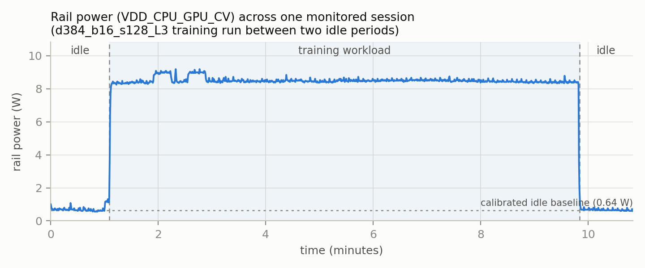

Figure 2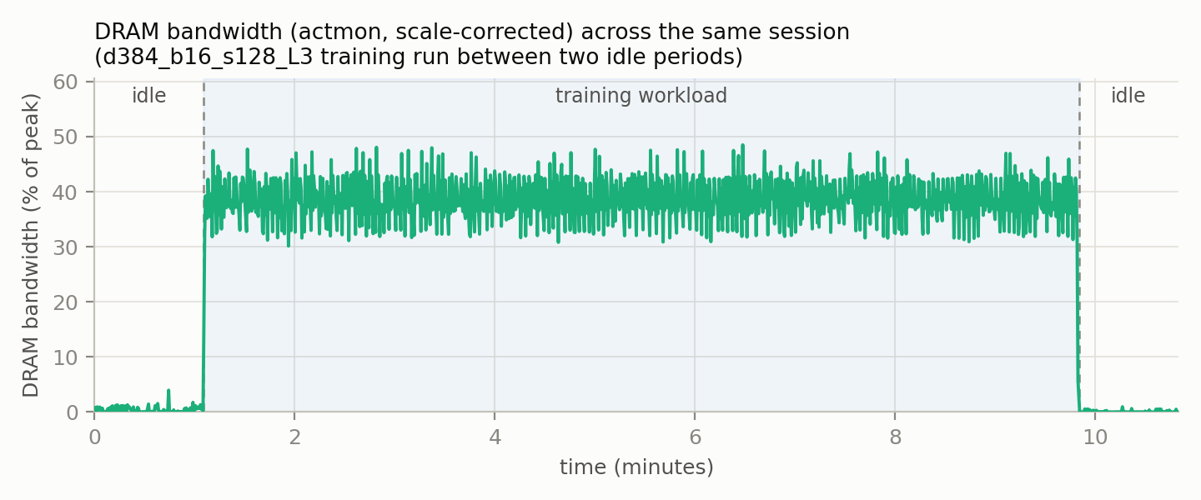

[Claude, I want you to describe the calibration evaluation suite here as an into to the next figure. Confirm that these are all workloads held out from calibration]
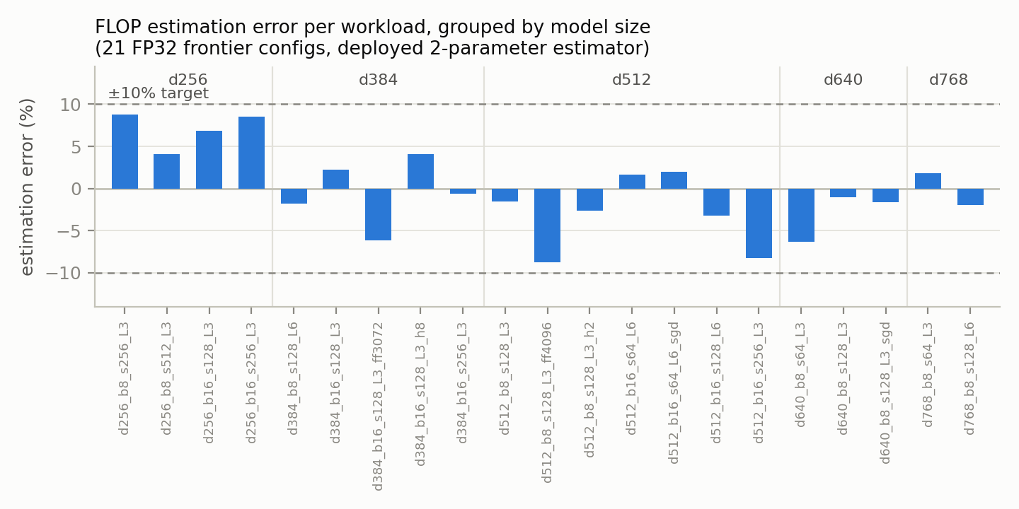

[Claude does this figure go with the above one? Is the above one not held-out, but this one is? If the data from this one was taken from a different run of the eval suite we’ll want to explain that again, but if not, we can include it under the same description as above]

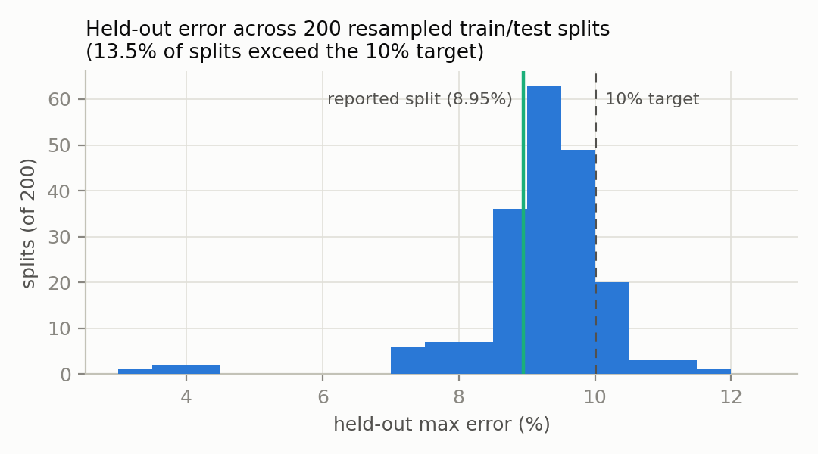

[Claude, into this next figure by saying what exactly the adversarial stuff is doing]
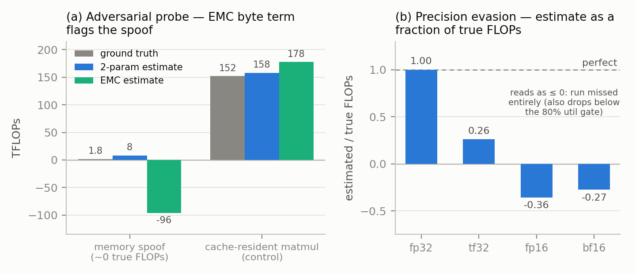

Next Steps

The Jetson Nano is a useful device for doing easy, non-compute-intensive experiments, but stress-testing FLOP estimation on real AI data center hardware would be more fitting to how we’d hope this would get used in a real verification situation. To extend this project towards that direction of a more realistic environment to an actual data center, I will replicate this on a dual-GPU V100 SXM2 node which I have physical access to. From here, I like to also incorporate the size of data transfer between GPUs during training as an additional input to the FLOP estimation model.

In addition to not being run on real AI data center hardware, another limitation of this initial, proof-of-concept experiment is the lack of adversarial testing. In a verification regime, not only do we need FLOP estimation to avoid having to rely on possibly-false self-reports, but we also must assume adversarial behavior on behalf of the AI model developers. Currently, my experiments only test if we can estimate FLOPs accurately on benign LLM training workloads, not workloads which have been adversarially designed to fool the estimator into outputting a lower FLOP count than what actually happened.

Other next steps which I think need to be done, but I am not currently prioritizing:
- Reframing FLOP estimation accuracy as false positive/negative rate for a classification of a training load as above/below a certain threshold. This would allow us to, say, tolerate a higher rate of false positives than false negatives.
- Security challenges: we both want to make sure verifiers don’t get too much access that they can uncover secrets about the training run and we want to make sure model developers can’t directly hack the estimator.
- I expect FLOP estimation would be best suited as another layer of swiss cheese than as the end-all be-all threshold for what is an allowed vs disallowed training run. Future work should include incorporating it into other forms of verification.

I am interested in getting feedback on any interesting next steps I am missing and on this project in general.

Thanks to … for their help on reviewing an earlier version of this report

This work is supported by the University of Chicago Existential Risks Laboratory

